* Build a Jenkins build server for the development team

Jenkins is an open-source automation server that integrates with a number of AWS Services, such as AWS CodeCommit, AWS CodeDeploy, Amazon EC2 Spot,and Amazon EC2 Fleet. You can use Amazon Elastic Compute Cloud (Amazon EC2) to deploy a Jenkins application on AWS in a matter of minutes.

## Step 1: Launch an EC2 Instance

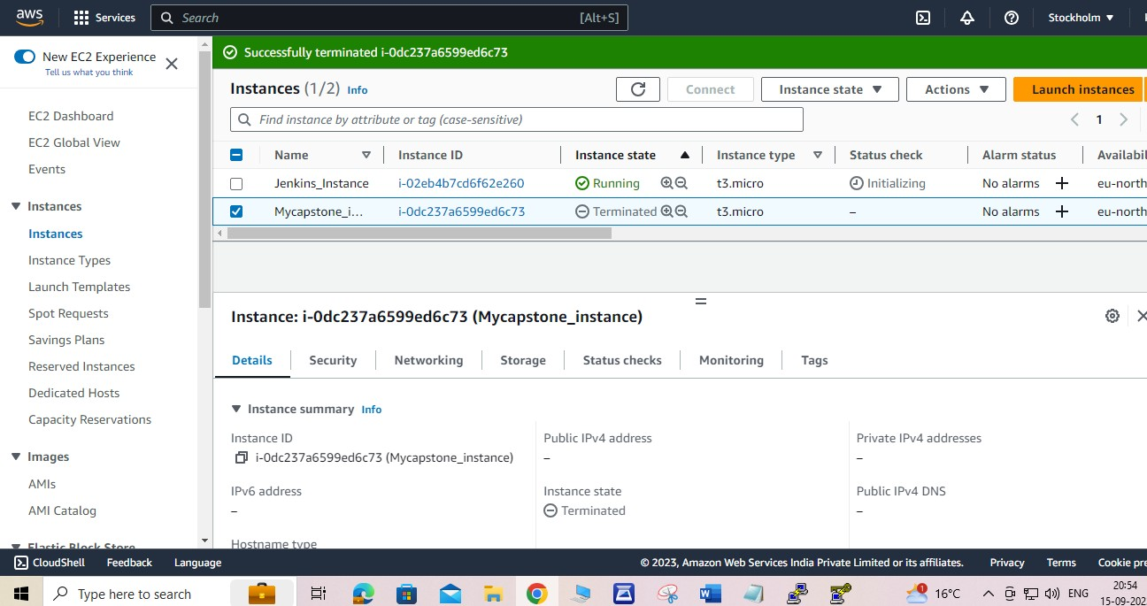

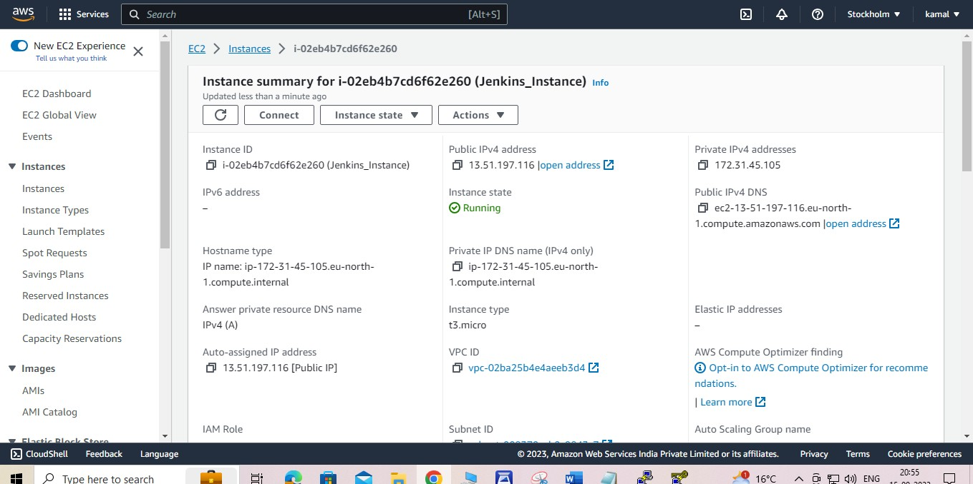

### Step 2: Install and Configure Jenkins

Using PuTTY to connect to instance.

* Ensure that your software packages are up to date on your instance by using the following command to perform a quick software update:

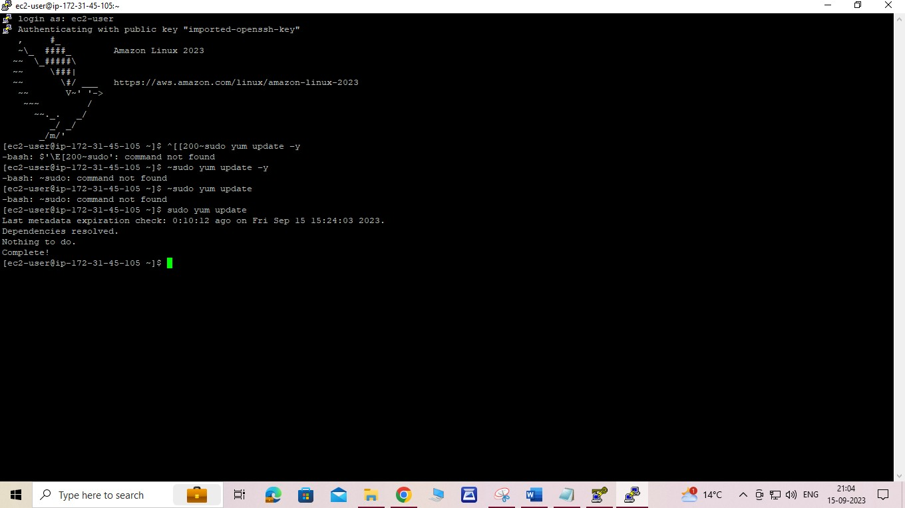

Add the Jenkins repo using the following command:

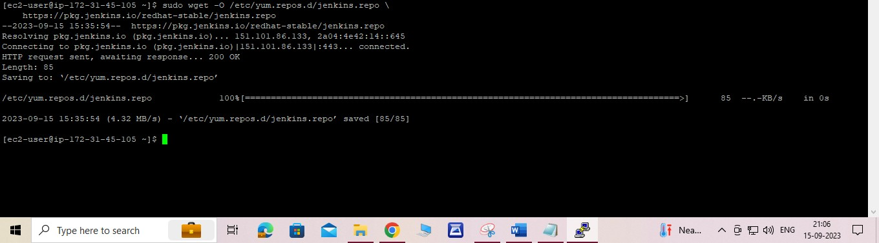

Import a key file from Jenkins-CI to enable installation from the package:

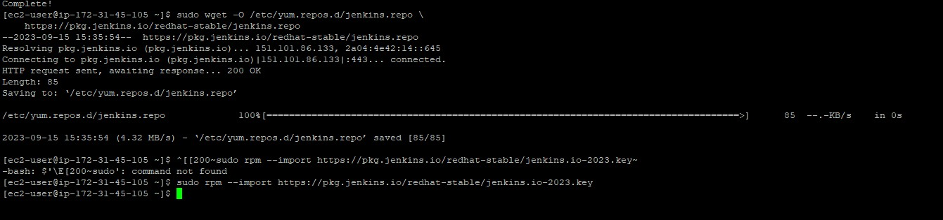

## 4. Install Jenkins:

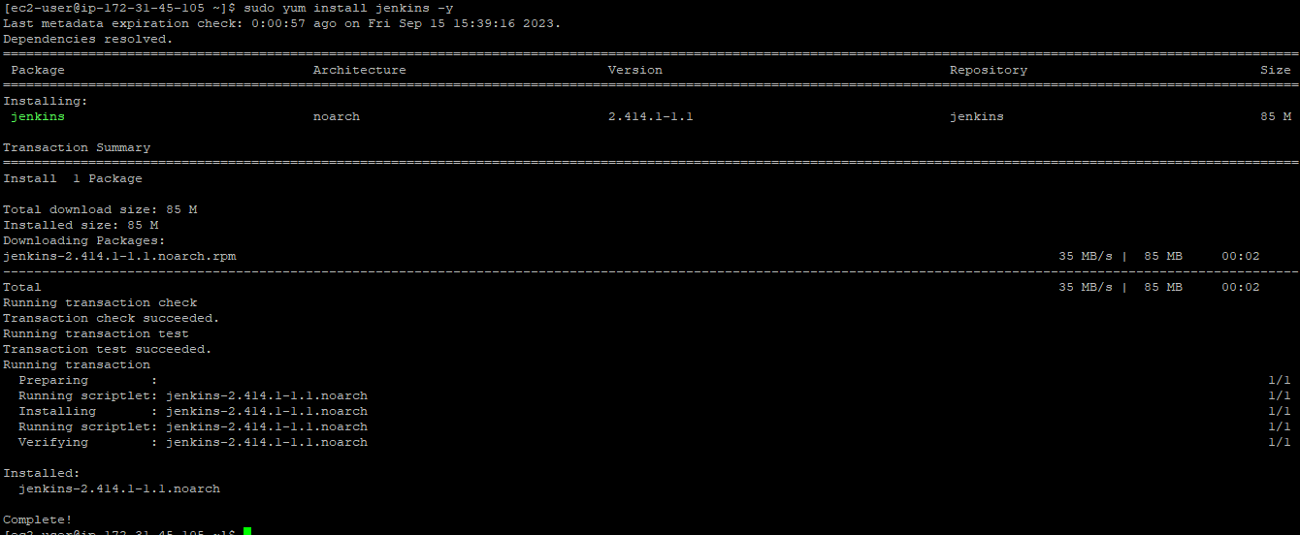

Enable the Jenkins service to start at boot:

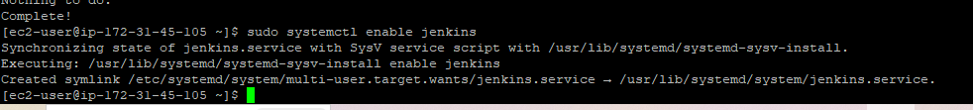

## Start Jenkins as a service:

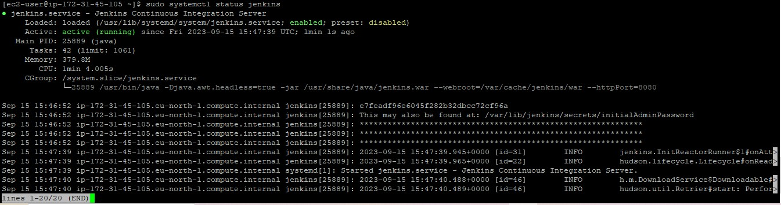

### Step 3: Configure Jenkins

Jenkins is now installed and running on your EC2 instance. To configure Jenkins:

Connect to http://ec2-13-51-197-116.eu-north-1.compute.amazonaws.com:8080 from browser. Will be able to access Jenkins through its management interface:

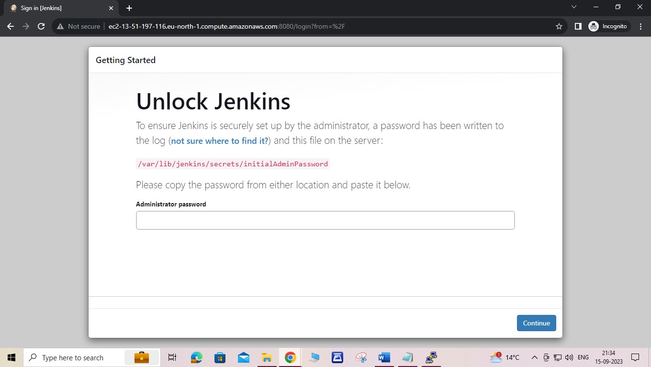

Select the checkbox next to **Amazon EC2 plugin**, and then select **Install without restart**.

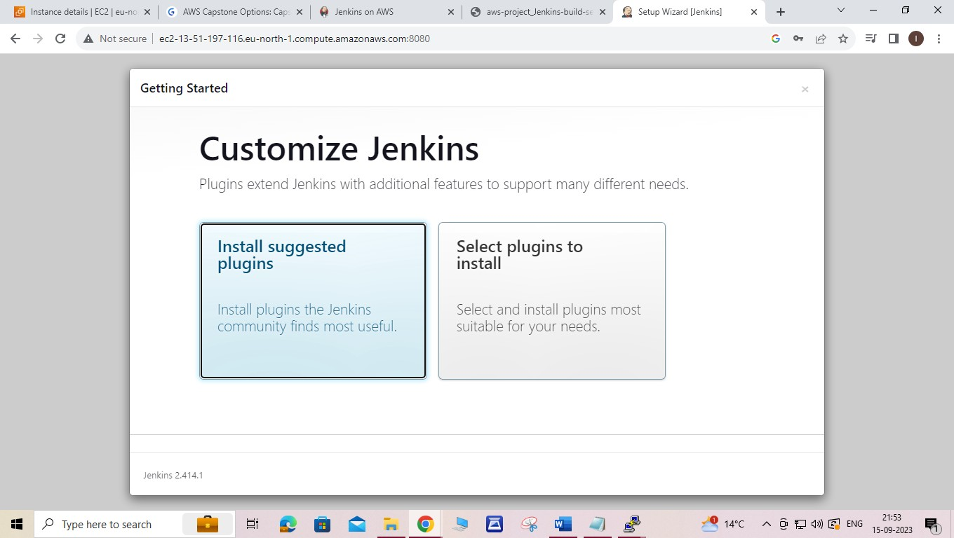

* On the left-hand side, click Manage Jenkins, and then click Manage Plugins.

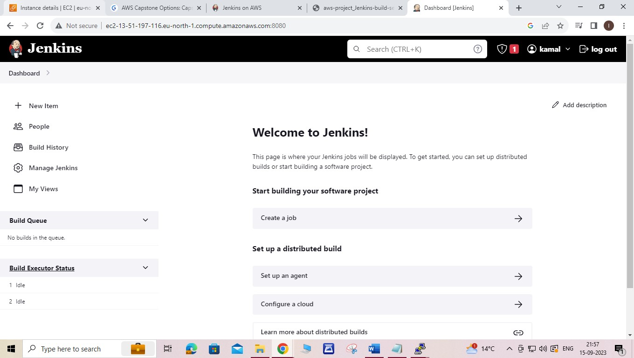

* Click on the Available tab, and then enter Amazon EC2 plugin at the top right.
* Select the checkbox next to Amazon EC2 plugin, and then click Install restart.

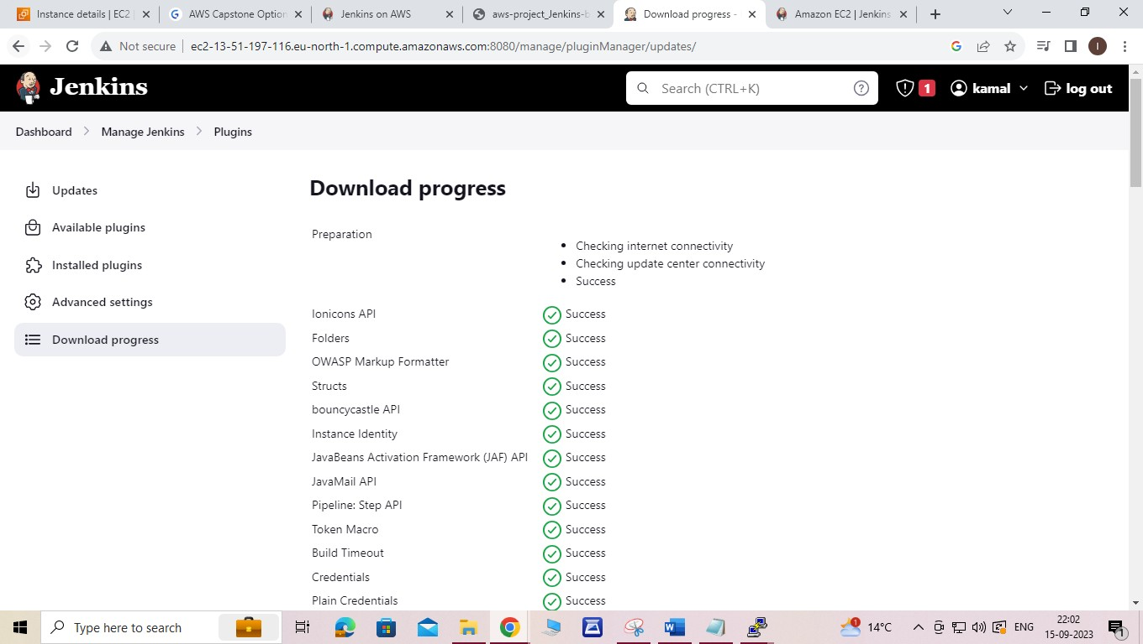

* Once the installation is done, click Go back to the top page. 9. Click on Manage Jenkins, and then Configure System.

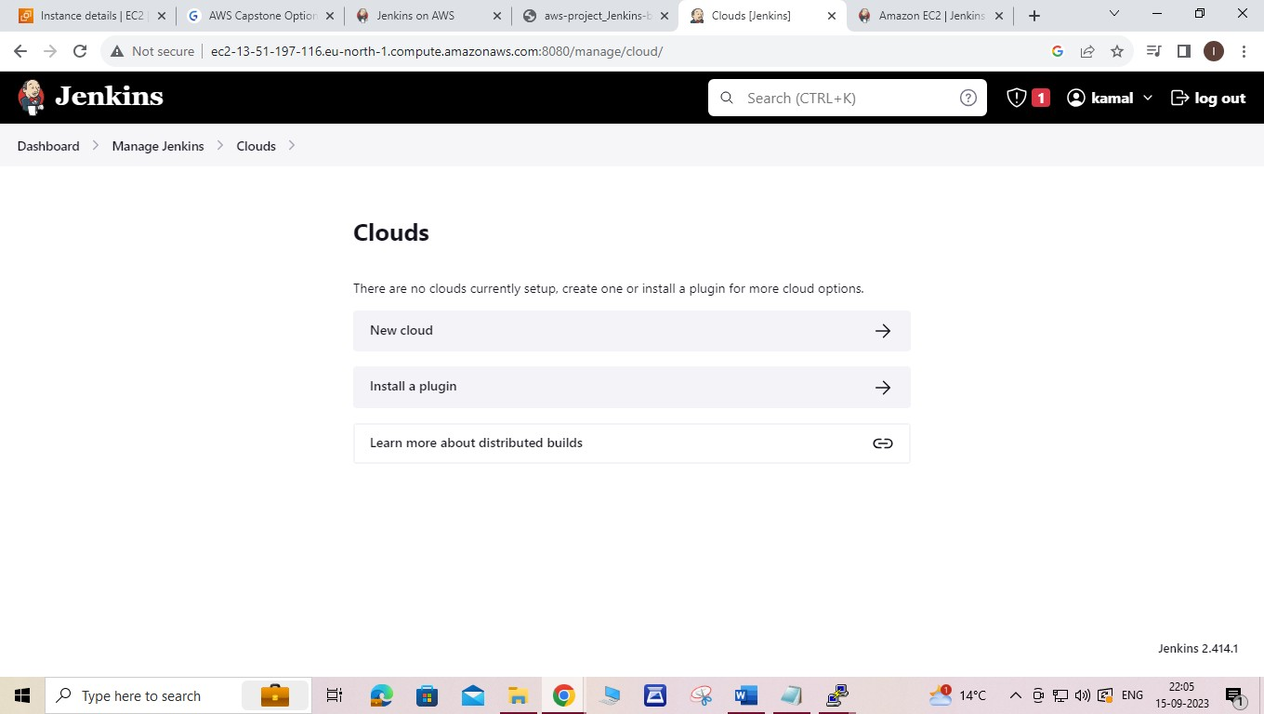

* Click on Manage Jenkins, and then Configure System.
* Scroll all the way down to the section that click Cloud.

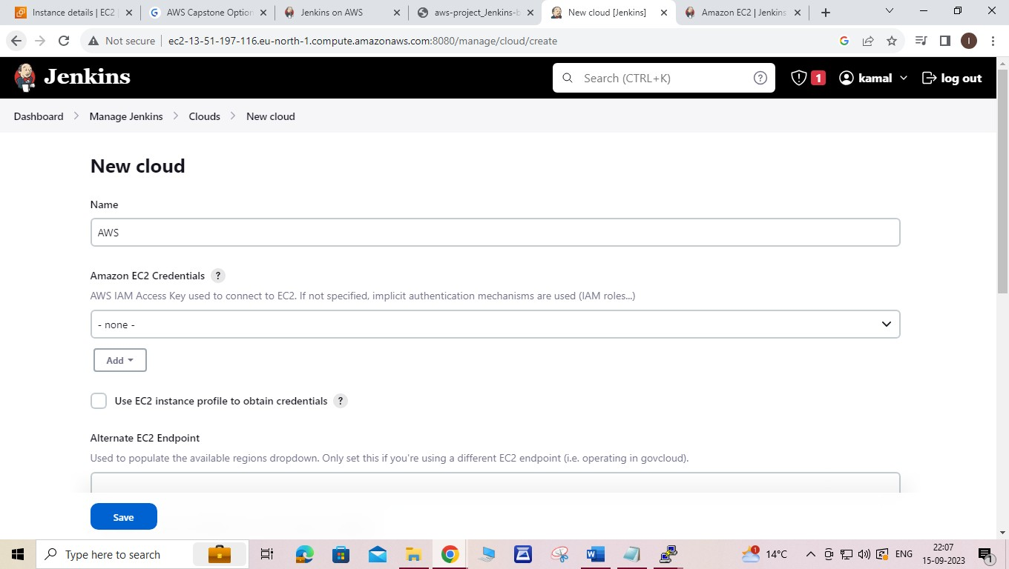

Scroll down to select your region using the drop-down, and select Add for the EC2 Key Pair’s Private Key.

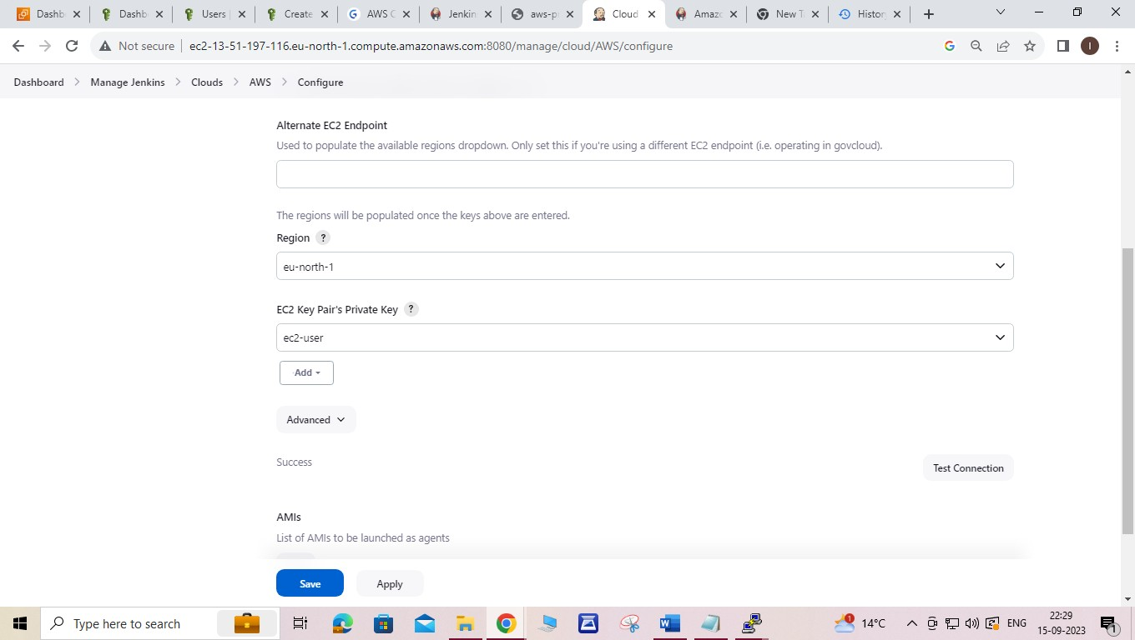

We are now ready to use EC2 instances as Jenkins agents.

**Step 4: Clean Up**

Be sure to delete the AWS resources that you created so that you do not continue to accrue charges.

* Deleting your EC2 instance

In the left-hand navigation bar of the Amazon EC2 console, select Instances. Right-click on the instance you created earlier and select Terminate.

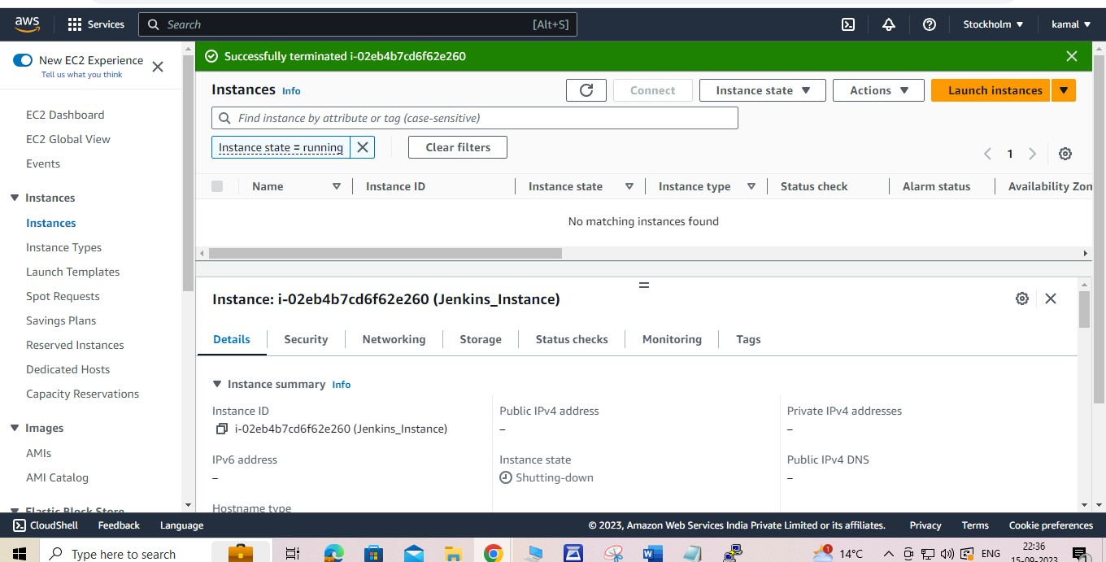

*************************End*****************************